KoG Property Committee Meeting Minutes
June 8, 2023
Attendance: Ron Nearman, Wayne Bradburn, Jack & Becky Newberry; Dean Falk (out of town)
Meeting convened at 7:05 pm and adjourned at 8:15 pm
The Committee members used this meeting time to review the items listed for the June 17th Work Day (reschedule from June 10th so as not to conflict with Margaret Reed’s Memorial Service.
- Flush Drain in library bathroom – Dean or Jack will cover; group suggests that AA and other guests be encouraged to use other restrooms because of the known situation with this drain.
- Check interior lights – east side of sanctuary, wall fixture – this bulb replaced by Wayne on 6/9/2023
- Check exterior lights – one out at south entrance door, the two decorative square light fixtures at north entrance – agree this is a ‘back-burner’ project for appearance only.
- Hang bulletin board along hallway of east entrance – first find out whether any group wants to use this bulletin board and then determine next steps.
- Remove sofa/misc items from back hallway by the Quilters room – further discussion about listing sofa on FB Marketplace for free pickup
- Delime the dish sanitizer in the kitchen quarterly (next due in August)
- Check roof and gutters – clear of pine needles/debris and standing water.
- Check for trash inside wooden enclosure for transformer in front yard
- Repair or look into replacement of debris guard above entrance to vault in driveway, east of property shed. Ron will consult with Curtis CleanSweep for ideas on replacement and control of this area to prevent flooding in the tool shed.
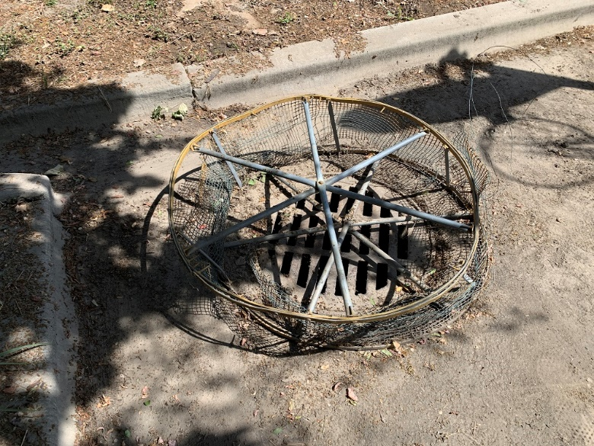
- Check cigarette ash container for time to empty
- Landscape related:
  - Enlarge area at base of magnolia tree so additional memorial stone can be placed for Louise Moore – Property Committee feels the family who planted the tree should participate in the care of that area. Original agreement was between the Moore Family and Pastor Kari Sansgaard.
  - Cut down weird looking arbor vitae on the west side of building
  - Remove 2 salvia plants from the middle back island
  - Trim the limbs of the lilac bush on west side of building
  - Check on locust seedling transplanted to back corner island, nearest the shed
  - Remove the dead barberry bush on the back corner island
  - Shrubs on east side of building need trimming
  - Weeding as needed along fence lines and parking lot islands
  - Should we repair (again) the cracks in the sidewalk that runs along the north side of the building – Wayne shared an estimate from Mr Mudd from August 2021 (attached). The damaged sidewalk on the south side was replaced at a cost of about $1700 but the work on the north side was postponed.
  - Downspouts on north side of building, to direct water further away from sidewalks and building foundation – this should be a part of the sidewalk repair/replacement project.
- Maintenance for Mowers and Trimmers – Jack The Toro lawn mower will be checked again to determine why it is so hard to start.
- Lawn Fertilization – contacted TruGreen and signed contract quote on 2 applications of weed/feed for the season. First application occurred 6/7 and backlot weeds were sprayed this past week also by Ada County Weed Control.
- Lawn Mowing Schedule: shared schedule posted in the Fellowship Hall and online with Google sheet: https://docs.google.com/spreadsheets/d/1YOTPc_-Aw9G2Cf5LCEjTaBpynxbyb9Du/edit?usp=sharing_eil_se_dm&rtpof=true&sd=true&ts=643980e6
- Irrigation Update – Wayne
  - Doneta is requesting a check of the irrigation line along the north side parking lot, she would like to add more iris there. Wayne will work with Doneta for irrigation at the locations she chooses.
- We will need to address some cosmetic repairs on the narthex walls where leaks were discovered earlier this year (HVAC units had their canvas ducting replaced). Consult with Ron Nearman. Kudos to Ron, he has completed these tasks as of 6/9/2023!
- One pole light not working, near the street at NW corner parking lot entry. Power disconnected within pole because neighbor reported it was ‘strobing’ at night. Advice is to wait until a second pole light needs attention before arranging for a service call by Mountain Power.
- Empty metal cabinet, locked without a key to open, needs services of a locksmith, if Pastor Connie would still want to use this cabinet for God’s Play materials storage.
- Boise Fire Dept performed their annual inspection on Friday, 6/9/2023, Becky met Dana Larrondo at 9:00 am for the walk-thru. Separate email sent about a few recommendations to address during a future work day.
- Veolia was contacted by email on 6/9 to address the appearance of the east parking lot for debris/damage from heavy truck use. They plan to have Curtis CleanSweep pay us a visit to address this.
- Pastor Connie spoke with Ron about the need to further clean the office that was shared by Laurann and Seth to get it ready for the arrival of the new Director of Music Ministry.
