KoG Property Committee Meeting Minutes
July 13, 2023
Attendees: Jack & Becky Newberry, Ron Nearman, Wayne Bradburn, Dean Falk, Harold Nesbett (Joel Tompkins-excused)
A report was provided on the Fire Sprinkler and Extinguisher Inspections, completed on July 5, 2023. Three extinguishers were swapped out for full ones. Five burned out fluorescent tubes were taken to the monthly HHW disposal location in the Cole Library parking lot. Ron reported on the project to refurbish the office for the new Director of Music Ministry. He is happy to do the repainting of the interior walls. However, for furniture arrangements, the Property Committee feels that the members of the Worship & Music Committee will want to participate.
Wayne reported some irrigation sprinkler repairs completed in the east lawn where tree roots had disrupted 4-5 sprinkler heads’ operation. He is also monitoring dry spots on the west lawn and moved the location of a sprinkler located near the transformer enclosure. Fresh ground cloth and bark have been laid down in the interior of that enclosure around the transformer.
Harold took the Toro lawnmower home to service it and it now starts easily again. Ron donated his edger and has stored it in the north shed, group suggests a monthly edging task during the summer months.
Dean will research whether the yew shrubs we have planted onsite are in violation of any new city ordinances. He will be taking a sample to the local extension office also to confirm the species of yew we have growing onsite. There are a number of those shrubs onsite, so it would be a considerable project if we had to remove them.
Ron suggested that we be more vigilant about sweeping the parking lot of debris and weeding the east parking lot islands.
Wayne cleaned a carpet spot outside the copy/work room. He has also been monitoring the amount of wine stains on the carpet in the sanctuary and plans to shampoo carpet areas in August timeframe.
Wayne would like to put a watch on some seams of the flat roof covering and also contact Ken Reglin about his knowledge of the details on that project so we will know which roofing company to contact if we see issues.
On Saturday morning, evidence of partying in back parking lot was found by Wayne. One broken glass bottle and 3 empty cans that had contained alcoholic beverages. Becky called Ada County non-emergency Dispatch to document the event. There was no need for an officer to visit the site.
Among the tasks addressed during the July 15th workday were:
- Flushed Drain in library bathroom-monthly task
- Door closer adjustment needed
  - Kitchen door to Narthex not completely closing
  - Exit door to Columbarium Garden is slamming shut
  - Exterior door to office area off the Narthex
  - North exterior entrance doors especially right one is slamming shut
- Several Tasks from Boise Fire Dept Inspection
  - 2nd floor fire escape door sticking, needs to open/close more smoothly-Harold completed
  - Replace batteries in upstairs exit sign at beginning of hallway-batteries have been ordered by Wayne
  - Remove blue tape from exit sign, first floor hallway near Forum-removed by Joel
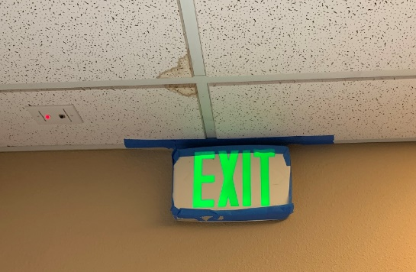
- Blue tape removed from ceiling vent in front Admin Office. If a draft is noticed, we will look into plastic vent that attaches magnetically.
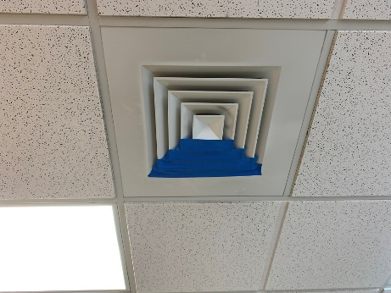
- Bulletin board has been adopted by ‘Days for Girls’ group-and has been hung
- Remove sofa/misc items from back hallway by the Quilters room – couple with Music Director office desks to be removed. Can be arranged through St Vincent de Paul pickup.
- Wayne completed the huge task of cleaning the roof and gutters – found remains of one bottle rocket from the 4th of July neighborhood celebrations.
- Check for trash inside wooden enclosure for transformer in front yard
- Five bags of rocks purchased by Ron for surrounding the vault opening of the back parking lot. The wire enclosure has been set aside in storage for now while we observe how well the parking lot debris is prevented from entering the vault drain. We plan to speak with the neighbor at 8885 W Cornwall about their method of draining water from their above-ground pool in their backyard. It causes erosion on our side of the property and neighbor should be informed that the vault is not a city storm drain.
- Wayne also mentioned that the vault drains into a field of underground rocks, the location is somewhere east of the vault and could be buried under existing parking lot area or our into the vacant field area planned for the LEAP affordable housing.
- Check cigarette ash container for time to empty.
- We investigated the state of the picnic table on the back lawn - that the bench seat on one side of the picnic table is loose and needs to be refastened securely, as well as one of the table slats has come unfastened also.
- Landscape related:
  - Should we repair (again) the cracks in the sidewalk that runs along the north side of the building – Wayne shared an estimate from Mr Mudd from August 2021 (attached). The damaged sidewalk on the south side was replaced at a cost of about $1700 but the work on the north side was postponed.
  - How about modifying downspouts on north side of building, to direct water further away from sidewalks and building foundation.
- Maintenance for Mowers and Trimmers – Jack
- Lawn Mowing Schedule: shared schedule posted in the Fellowship Hall and online with Google sheet: https://docs.google.com/spreadsheets/d/1YOTPc_-Aw9G2Cf5LCEjTaBpynxbyb9Du/edit?usp=sharing_eil_se_dm&rtpof=true&sd=true&ts=643980e6
- Questions from Carolyn Watts – Community Garden: we need more info from Carolyn on what she would want to be done. For part b, we are deferring this question to present to Church Council.
  - ​ "Green" garden debris. Before I took over, garden debris throughout the season was thrown into the church dumpster. However, this put many gardeners in a very difficult spot because the dumpster is far away on a hot day, quite tall, difficult to open, and for short people, almost impossible to dump things into. They had to throw it in handful by handful from wheelbarrows. I experienced that myself last year, trying to get a huge tarp of goathead plants lifted into the dumpster. And we are talking enormous amounts of green waste such as spent pea plants. If you look in the garden, you will see this is equal to several yards of debris. We can rent a dumpster at the end of the season like they used to, but it is about fivel hundred dollars, and doesn’t help throughout the summer.
  - ​Compost. We HAVE to have compost. The manure that used to be delivered took up a substantial amount of space, which we have pared down as we switched to the free City compost. However, the truck that delivers the free City compost has to back up to a spot and dump out the back, so the only available spots, by the garden shed and the cherry tree, are not reachable. At the last LEAP info meeting at the church, I had mentioned that we would need to dump it in two parking spots in the parking lot, but I’m not sure folks actually took me seriously. If we can’t dump it in spots next to the peach trees, I need an alternate spot. I really REALLY don’t want to have to kick out a gardener who has been there for years just to store compost. Realigning the entire garden and shrinking the lots to accommodate compost is a huge undertaking, especially since we just spent a lot of time and money to replace the old, leaking irrigation.

- One pole light not working, near the street at NW corner parking lot entry. Power disconnected within pole because neighbor reported it was ‘strobing’ at night. Advice is to wait until a second pole light needs attention before arranging for a service call by Mountain Power.
- Copy of last invoice from Mr Mudd

